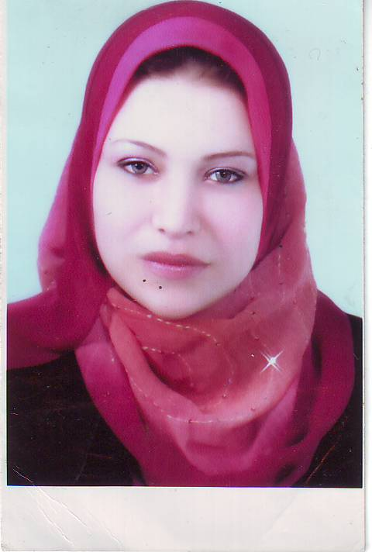
C.V

Personal Data:
- Full name: Amira Fathy EL-Sayed El-Gazzar
- Gender: female
- Birth Date: 20/7/1982
- Marital status: married
- Mobile: 0197774388
- E-Mail:elgazzar44@yahoo.com

Degree:
- Bachelor of Medicine and Surgery 2005, Assiut University (Excellent with degree of honor)
- Master of public health and community medicine 2009

Current Position:
- Assistant lecturer of public health and community medicine, Faculty of Medicine, Assiut University

Personal Skills:
- Languages: Arabic: mother tongue
English: fluent
- Computer skills: Good experience in Word, PowerPoint, Internet search
Average experience in Stata , SPSS, Epi-info

Experiences:
- Working for 3 years as a demonstrator of public heath and community medicine, faculty of medicine, Assiut university

- Passed with excellence MPH exams
- Completed a review on Impact of smoking and drug abuse on reproductive health of adolescence
- In the process of completing a systematic review on the impact of mobile clinics on women’s and children health (registered title & published proposal in the Cochrane collaboration)
- Worked on a research (Exploratory Study to Understand Reproductive Health Behaviors and Sexual Health Problems among Married Adolescent Girls in Egypt) funded by the population council
- Training coordinator for the population council project in Sohag,Egypt“Scaling up the provision of family planning messages in antenatal and postpartum services in Upper Egypt” 2011.
- Prepared and conducted the following workshops

1-Curriculum Development Workshop Series
1: Incorporating SPECTRUM in MPH 1st - 2nd March, 2009

2-Curriculum Development Workshop Series
1: Incorporating SPECTRUM in MPH 3rd - 4th March, 2009

3-SPECTRUM Program Applications for
Family Planning Directors 27th - 28th April, 2009

4-Curriculum Development Workshop Series
2: Incorporating SPECTRUM in MPH
for El-Minya Faculty Staff 5th June, 2009

5-Curriculum Development Workshop Series
3: Incorporating SPECTRUM in MPH
for Nursing Faculty Staff 20th ,21st October, 2009

6-SPECTRUM Safe Motherhood Module
For Maternal and Child Health Program Directors & their Assistants 2nd – 4th February, 2010

Courses:
Attended workshops and conferences

Reproductive health and development: analytic skills for policy and programs | 2008 | June 2-June 13 | Johns Hopkins school of public health, Baltimore ,Maryland, USA
Making evidence based decisions in reproductive health | 2008 | 13-15 September | Assiut University
مؤتمر الإقليمي الأول للمشكلة السكانية في صعيد مصر | 2009 | 1-2 April | (Assiut University cooperation with Population Reference bureau and Johns Hopkins school of public health
Communicating research results on population and reproductive health issues to policy audiences | 2009 | 20-24 December | Assiut University
Introduction to STATA | 2010 | 30 Jan-1 Feb | Assiut University
Introduction to Epi info | 2010 |  | Assiut University
Capacity Building Workshop to Enhance Research  and Programs on Youth Reproductive Health in Egypt | 2010 | 20–24 March | Population council
Qualitative methods for sexual and reproductive health | 2010 |  | Assiut university

Memberships in organizations:
- ECMA Organization,
- Egyptian smoking control association,
- Member steering committee of collaboration between Johns Hopkins School of Public health and department of Public health and Community medicine Assiut University
Publications:

Areas of interest : Reproductive health, breast cancer, maternal mortality

